Editor's Comments:  
  
Editor: 1  
Comments to the Author:  
Although the revised paper improved significantly, still the reviewers have important questions and comments on the paper. In particular, the explanation on the benefits of improved prediction accuracy is needed. Also, please provide clarification and detailed description on the results shown in figures 7 to 9. Furthermore, testing and validation on the results produced by the proposed methodology using meaningful data sets are needed.

Answer: Thank you for your valuable feedback. We have comprehensively improved the manuscript in the following three aspects: First, we have elaborated on the practical significance and application value of improving prediction accuracy. Second, we have updated the prediction results with rainy weather characteristics to more clearly demonstrate the model's performance under complex weather conditions. Third, we have adopted publicly available datasets to ensure the verifiability and reproducibility of our research findings. The specific modifications will be described in detail in the following sections. Once again, we appreciate your valuable comments and look forward to your further feedback.

Reviewer: 2  
Comments to the Author  
In the first review, the reviewer requested, "Please explain what kind of progressive effect this improvement in prediction accuracy will have," to which the author replied, " Case study results demonstrate that compared with current Transformer-GCN model, the precision of power prediction model proposed in this paper is increased by 11.90%, 15.72% and 23.03% respectively in sunny days, cloudy days and rainy days. " .  
This answer is meaningless because it simply states the results of improved prediction accuracy.  
The reviewer is requesting to "explain in detail what the BENEFITS OF IMPROVING PREDICTION ACCURACY WILL BRING." A description that merely improves the accuracy of the prediction is not worth this paper.  
Answer: Thank you for your valuable feedback. We fully agree with your perspective that the practical benefits of improving prediction accuracy need to be more clearly articulated in the paper. To address this, we have added the following content to the conclusion section of the paper:

High-precision photovoltaic power prediction enables grid operators to more accurately predict changes in photovoltaic power generation trends, thereby optimizing the operational plans of thermal power units in advance. For instance, when a decline in photovoltaic power generation is anticipated, thermal power units can be gradually ramped up to prevent power shortages caused by insufficient ramp rates. Conversely, when an increase in photovoltaic power generation is predicted, the output of thermal power units can be reduced in advance to avoid overgeneration. This coordinated optimization not only reduces the frequent start-stop cycles and ramp pressure on thermal power units, extending their operational lifespan, but also significantly lowers fuel consumption and carbon emissions, while enhancing grid stability and economic efficiency. Furthermore, accurate prediction facilitates better integration of photovoltaic power into the grid, reduces curtailment, and improves the utilization rate of renewable energy, thereby accelerating the transition towards a greener energy structure.

In the first review, the reviewer wrote, "Figures 7 to 9 show results in three different weather conditions, but the peak output of PV is quite high even in wet weather in Figure 9. In general, the PV output in rainy weather is less than half that of PV output in sunny weather. What kind of rainy weather did you expect? This means, "If it is assumed rainy weather, it should be assumed full-fledged rainy weather, which has a very different profile than sunny weather." In other words, the profiles of Fig. 7, Fig. 8, and Fig. 9 should have very different characteristics from each other, and it should be shown that the proposed method can achieve highly accurate predictions even under these conditions.　What is your view on this?

Answer: Thank you for your attention to and suggestions on the results presented in Figures 7 to 9. We have provided detailed explanations and optimizations for the relevant figures based on your feedback. The specific revisions are as follows:

Following your suggestion, we have replaced Figure 9 with prediction results that clearly exhibit rainy weather conditions. The new Figure 9 vividly illustrates the significant fluctuations in photovoltaic output power under rainy conditions and highlights the differences compared to sunny conditions: under rainy conditions, the maximum photovoltaic output power is only 35% of that under sunny conditions. This result not only demonstrates the significant suppression of photovoltaic power generation efficiency by rainy weather but also further validates the adaptability and predictive capability of the proposed method under complex weather conditions.



**Fig.7.** County Clear-Sky Prediction Results Comparison Chart.



**Fig.8.** County Cloudy Sky Prediction Results Comparison Chart

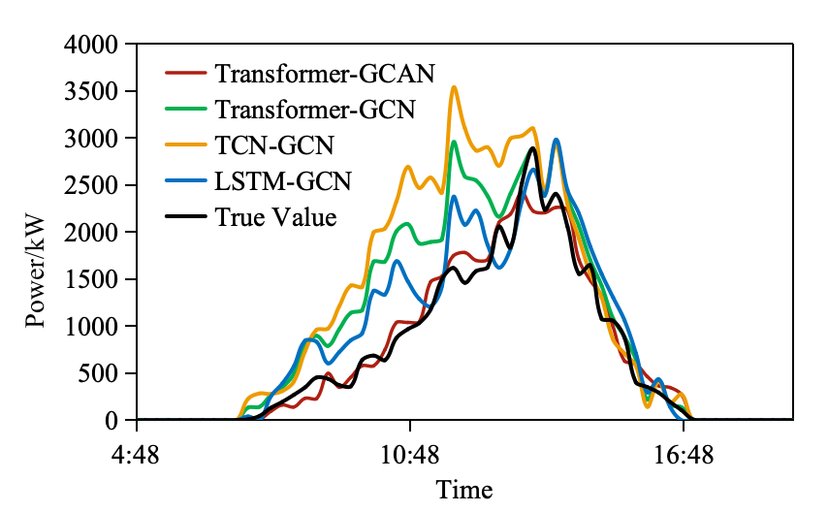

**Fig.9.** County Rainy Weather Prediction Results Comparison Chart

Reviewer: 3  
Comments to the Author  
The authors have answered to most of my previous comments. However, as a reviewer, i cannot test the results produced by the methodology, without the necessary inputs. The authors should try to reproduce the results using data sets that they can freely share with the scientific community.  
Unless this is done, i am afraid i have to propose to reject the paper.

Answer: Thank you for your thorough review and valuable feedback on our manuscript. We fully understand your concerns regarding data accessibility and the reproducibility of the results, and we take this matter very seriously.

To ensure the verifiability of our research findings, we have uploaded the dataset used in this study to a public platform (GitHub:https://github.com/6667tc/Data1), making it freely accessible to the scientific community to facilitate the replication of our experimental results.